Databricks Assignment [29-12-2023]

By Karthikeyan K R

Getting into Azure portal

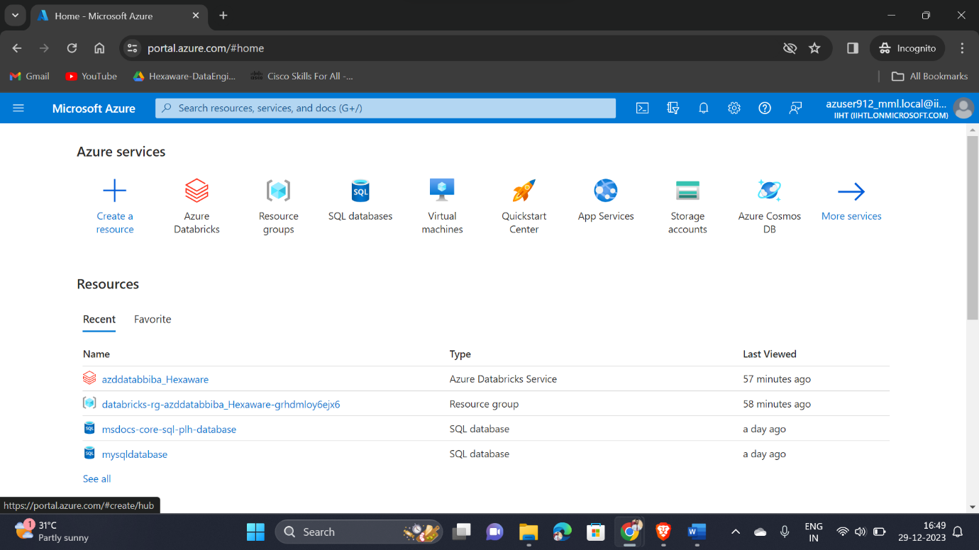

Choosing Azure Databricks Service and Launching the workspace

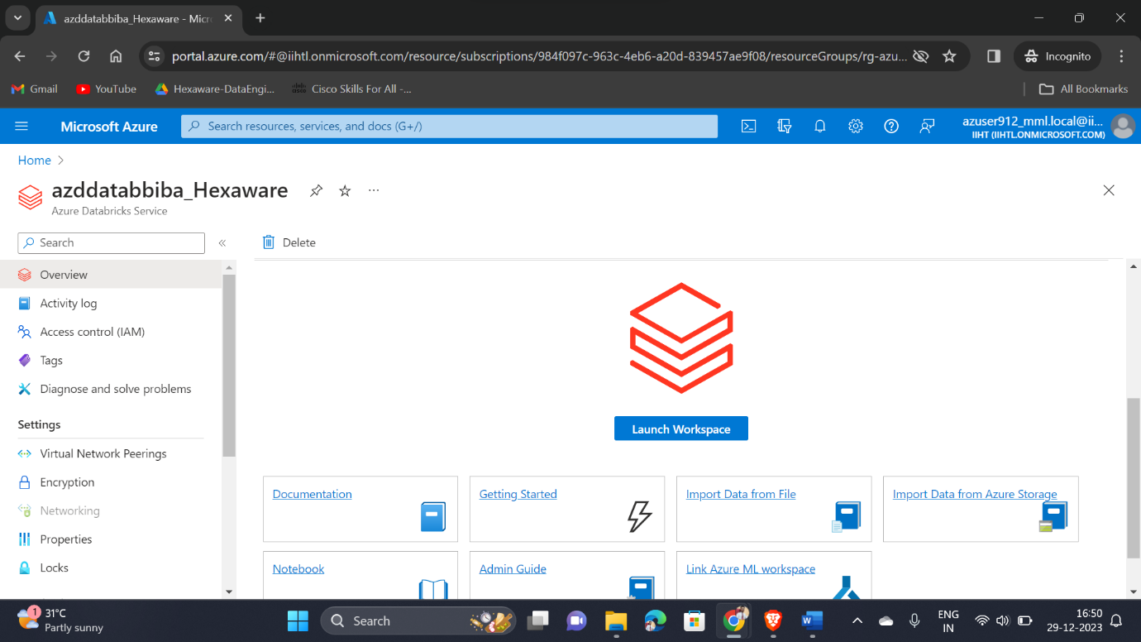

Redirecting and getting into Databricks Portal

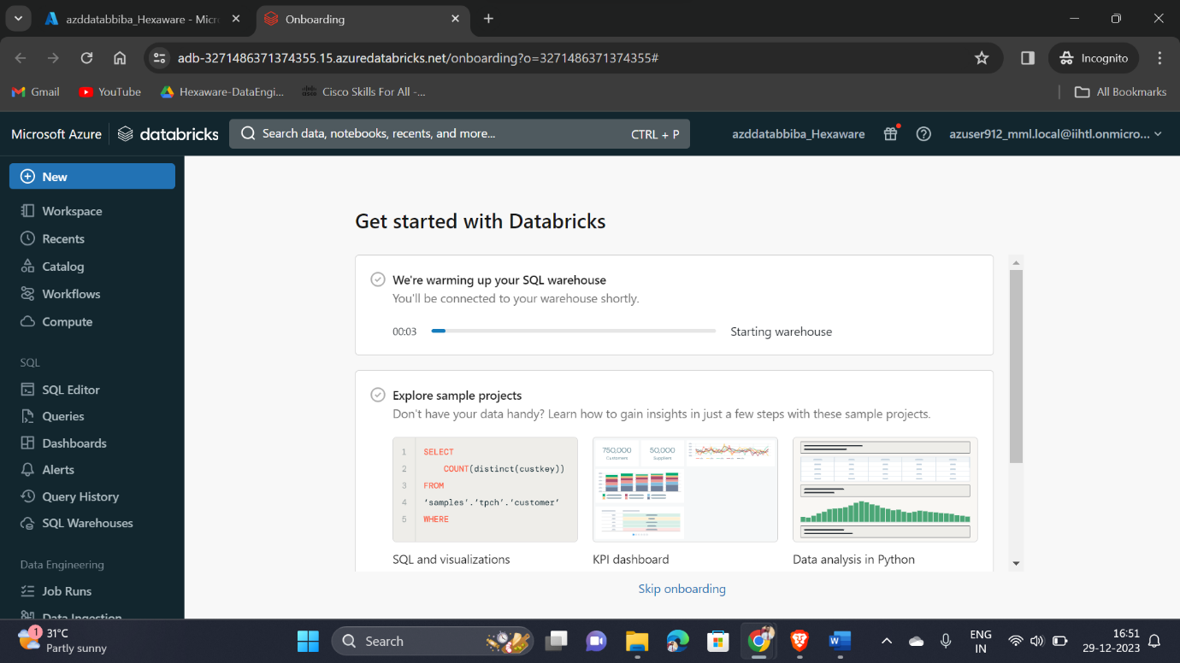

Creating a new Cluster for my notebook

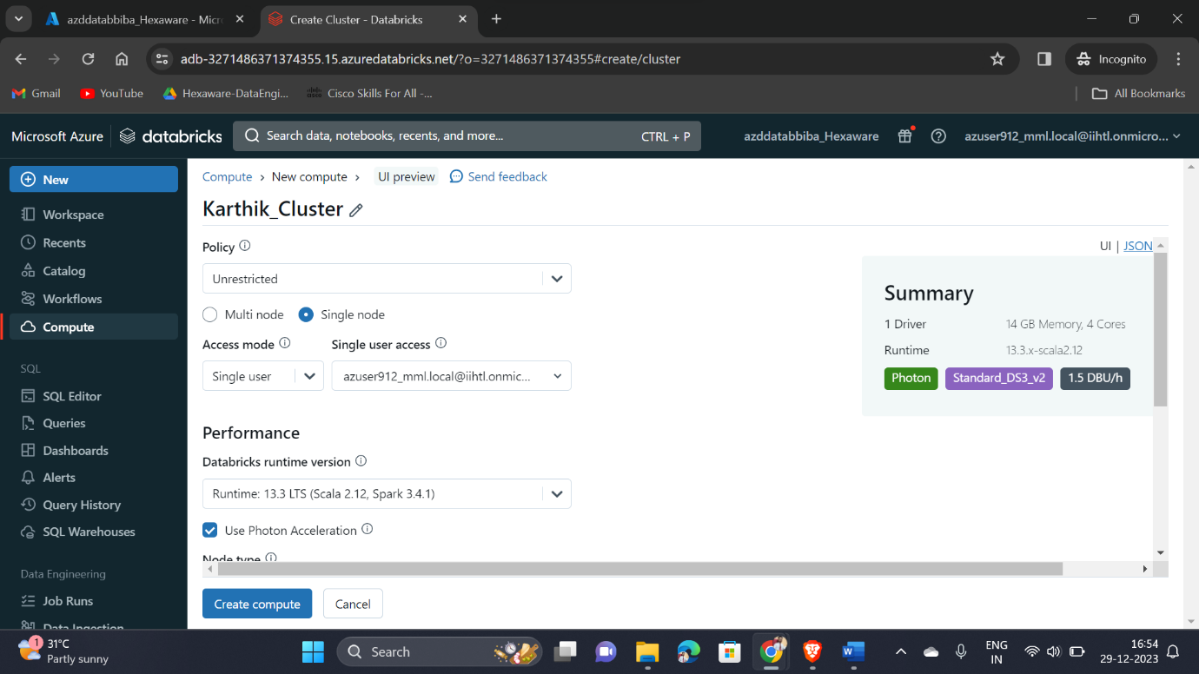

Once we successfully created the cluster, we can able to see the green tick near to the cluster name

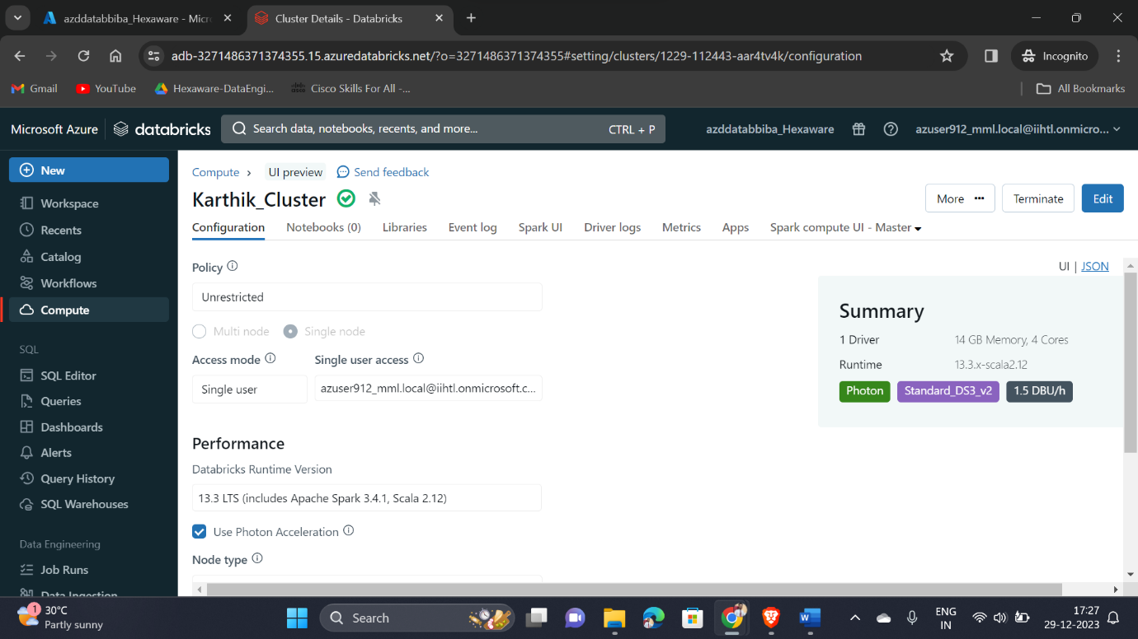

Loading the created cluster into my notebook

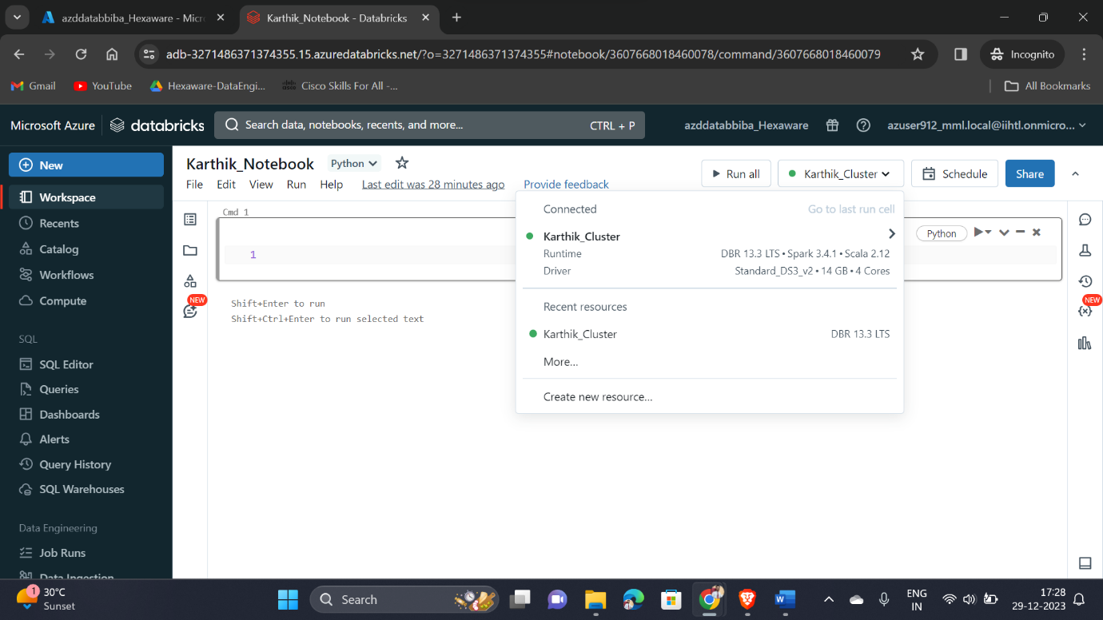

Executing the sample PySpark program using the created cluster

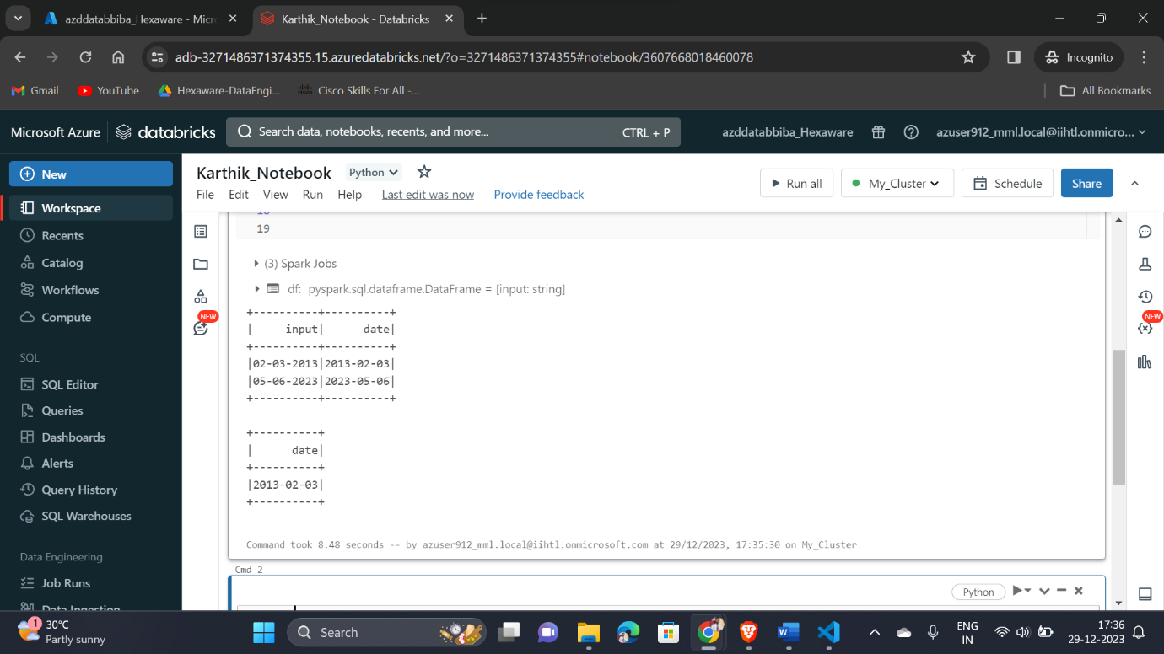

I have renamed cluster to My_Cluster and getting to see Spark UI

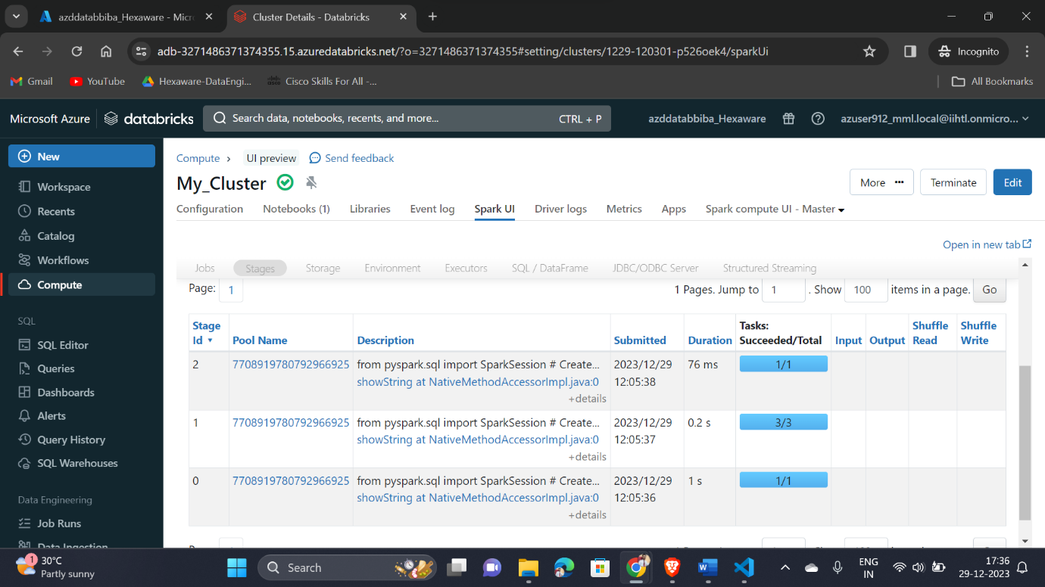

Number of Notebooks configured to my cluster

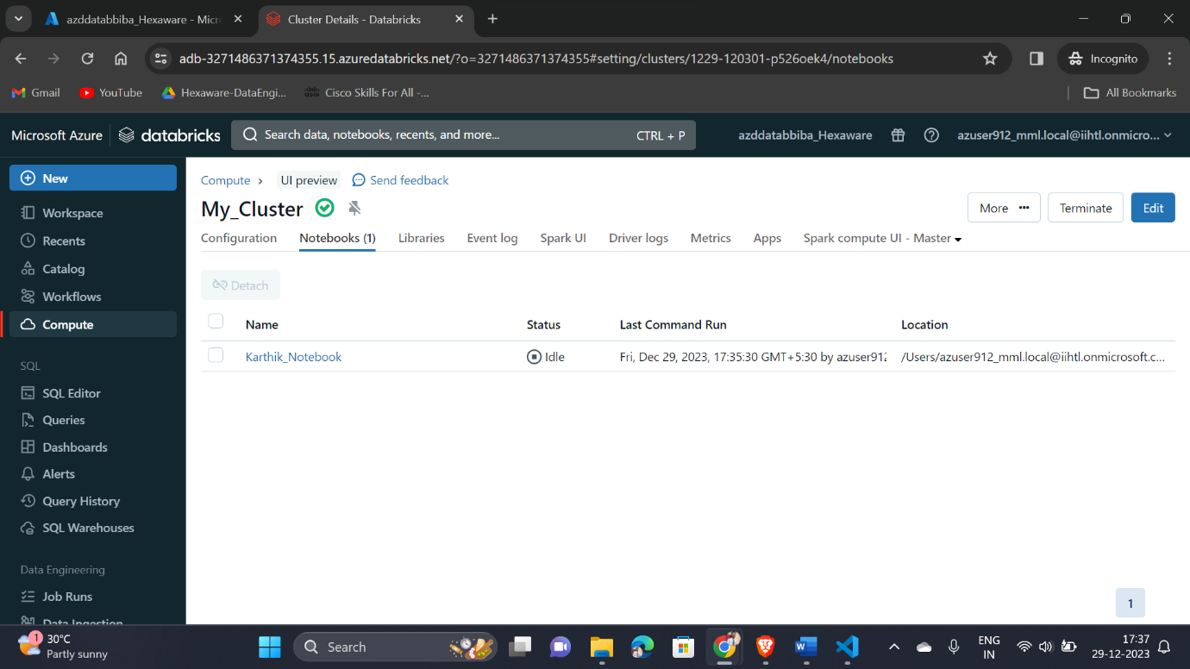

Finally deleting the created cluster once the work has been done

